Chapter 19, Solution 89

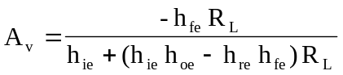
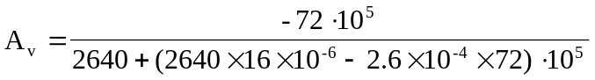
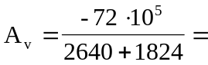

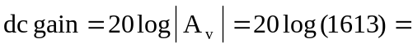dB

